**Title of this paper (Times New Roman, size:16pt, Bold)**

Author11

Author22,3

*1Affiliation1 & Address1*

*2Affiliation2 & Address2*

*3Affiliation3 & Address3*

(Received 2025 October 31; accepted 2025 November 21)

**Abstract**

This work is … On the other hand, … (Times New Roman, size:10.5pt)

First, …

Second, …

Finally, …

Therefore, …

**Key words:** stars: abundances − binaries: close

**1. Introduction** (Times New Roman, size:10.5pt, Bold)

This is a pen. (Times New Roman, size:10.5pt)

However, that is a pen.

**2. Observation**

*2.1. Target star and observation (Times New Roman, size:10.5pt, Italic)*

This star is …

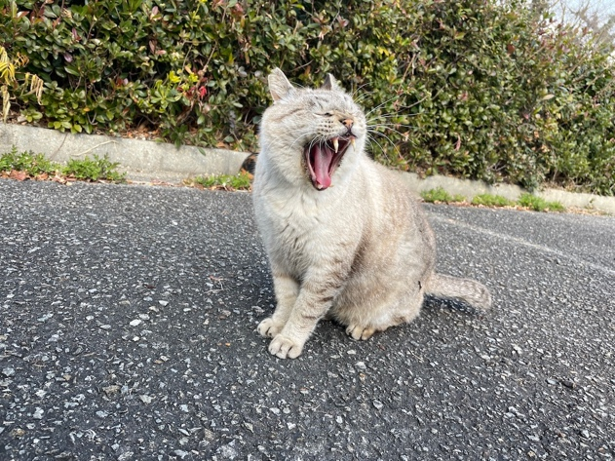

Fig. 1. This is a cat. (Times New Roman, size:9pt)

**6. Conclusion**

As I thought, this is a pen.

**Table 1.** Distance of the target stars. (Times New Roman, size:9pt)

|  |  |  |
| --- | --- | --- |
| Object ID | d [pc] | Remark |
| Tama | 52.4±0.3 | Times New Roman |
| Pochi | 26.6±0.2 | Size:10.5pt |
| Mike | 79.1±0.3 |  |

Appendix.

This is an apple.

**Reference**

Neko, C., Inu, D., & Cat, N. 2019, MNCAT, 24121, 19349